Log in
  - Go to: https://order.lildrugstore.com/
  - Then click on the Login button present on the top right of the homepage.
  - Click on the “Click here to login” button.
  - You will be directed to the login page. Enter your email id and click on the continue button.
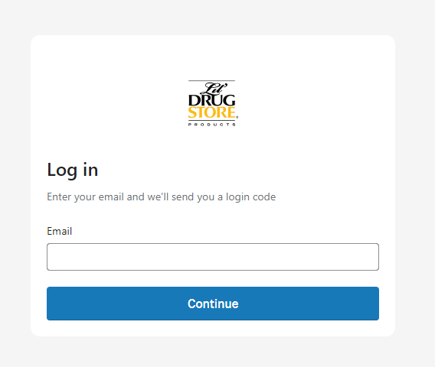
- You will receive a 6-digit code on the email entered. Enter the 6-digit code and press Submit. (check junk folder)
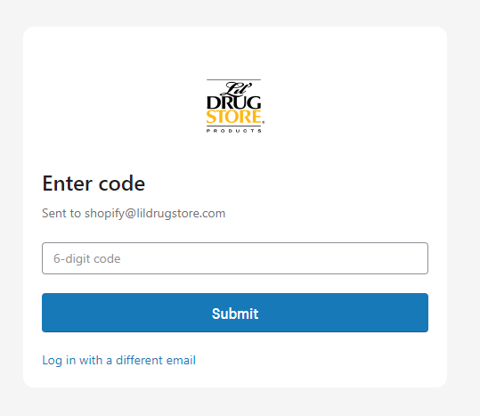
  - Once logged in, you will see the Orders page.
  - Click on the “Go to store” button present on the top right corner.
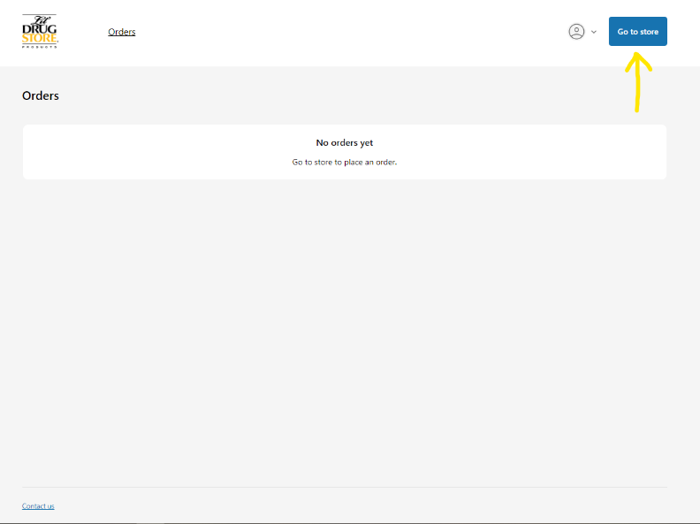
  - To navigate through the store, you can click through the navigation or the logo icon to visit the home page.
  - You can visit through the pages like Home page, sales resources and product catalog and FAQs
- Navigating
  - Product Catalog
  - Sales Resources
    - Price List
    - Planograms
- Reorder
- FAQs
  - https://order.lildrugstore.com/pages/faqs
Product Catalog
- How to filter
  - Filter on the left by
    - Collection
    - Price
    - Brand
  - Utilize product catalog collections
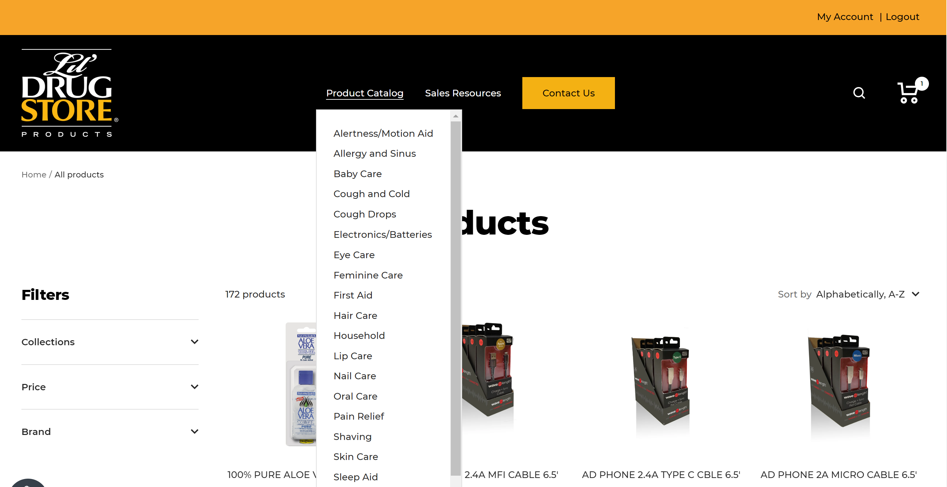

- Product detail page
  - Description contains pack size units per 1 quantity
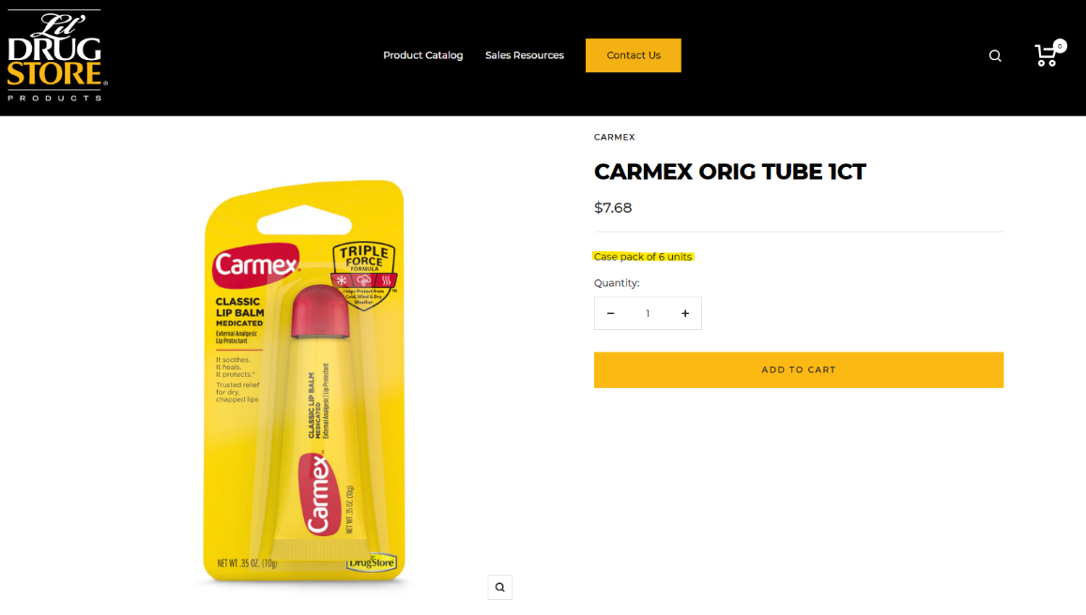

Sales Resources
- Contains Planograms, Price Lists, Transition Materials
  - Click on item to download a pdf
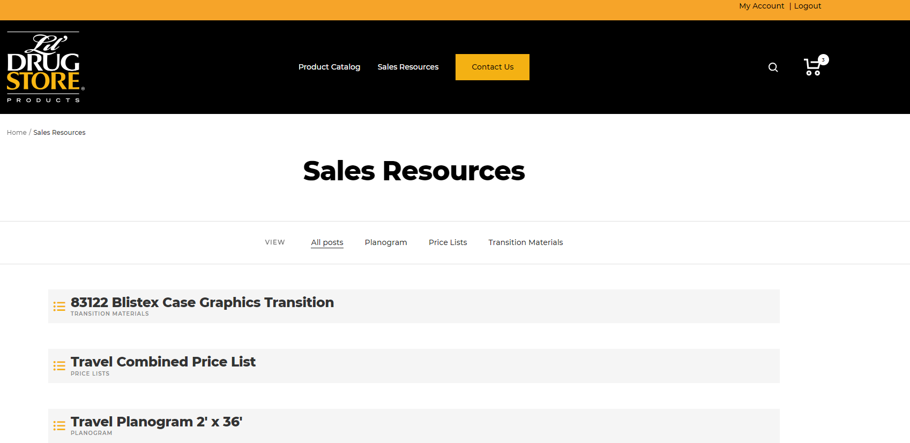

My Account
- Orders
    - Clicking on the “My Account” button on the top right corner of the site would take you to the “Account” page.
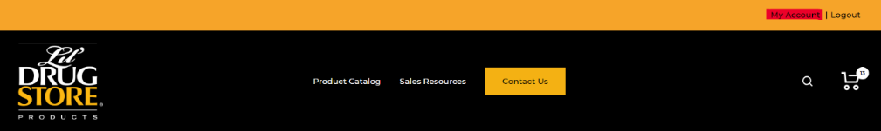
    - There is a “Buy Again” button right below every order.
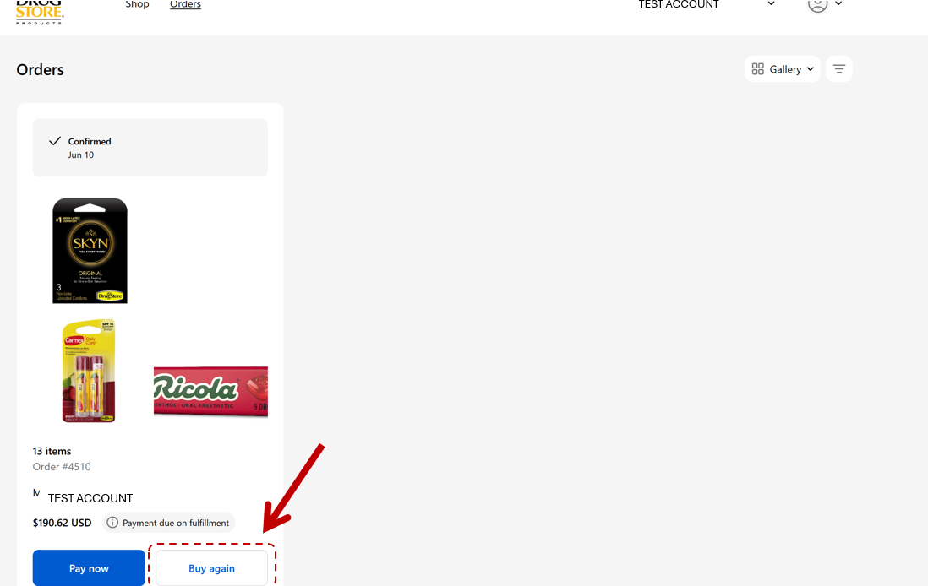
    - Clicking on the Buy Again button will directly open up the checkout page with the products and their quantities.
    - Quantities may be modified and additional products can be added as needed.
  - Reorder button on the order detail page
    - Clicking on any order will open up the order detail page.
    - Clicking on the Buy Again button will directly open up the checkout page with the products and their quantities.
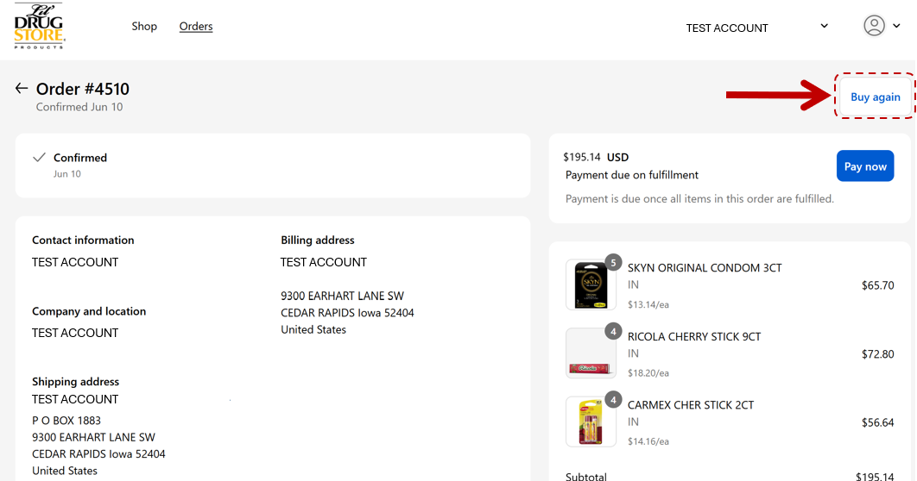

- Profile information – email, address, etc.
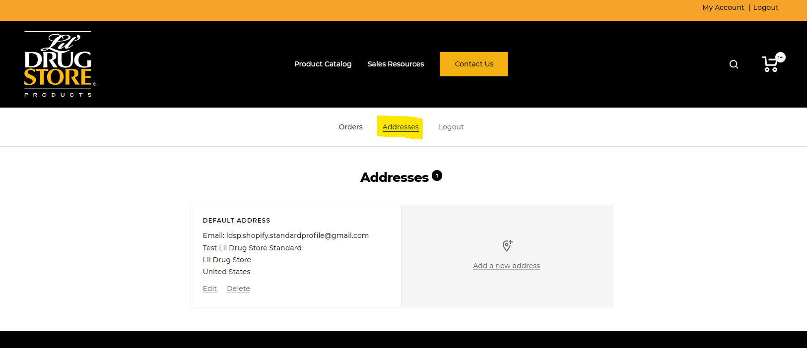
    - Edit current
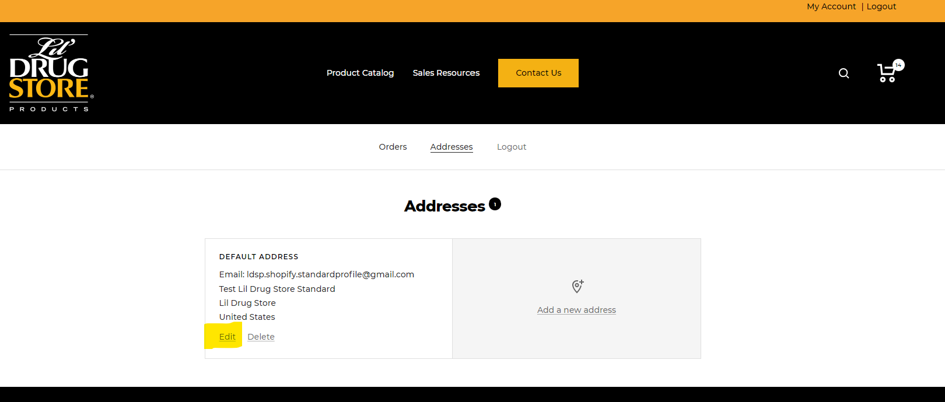
    - Add new address

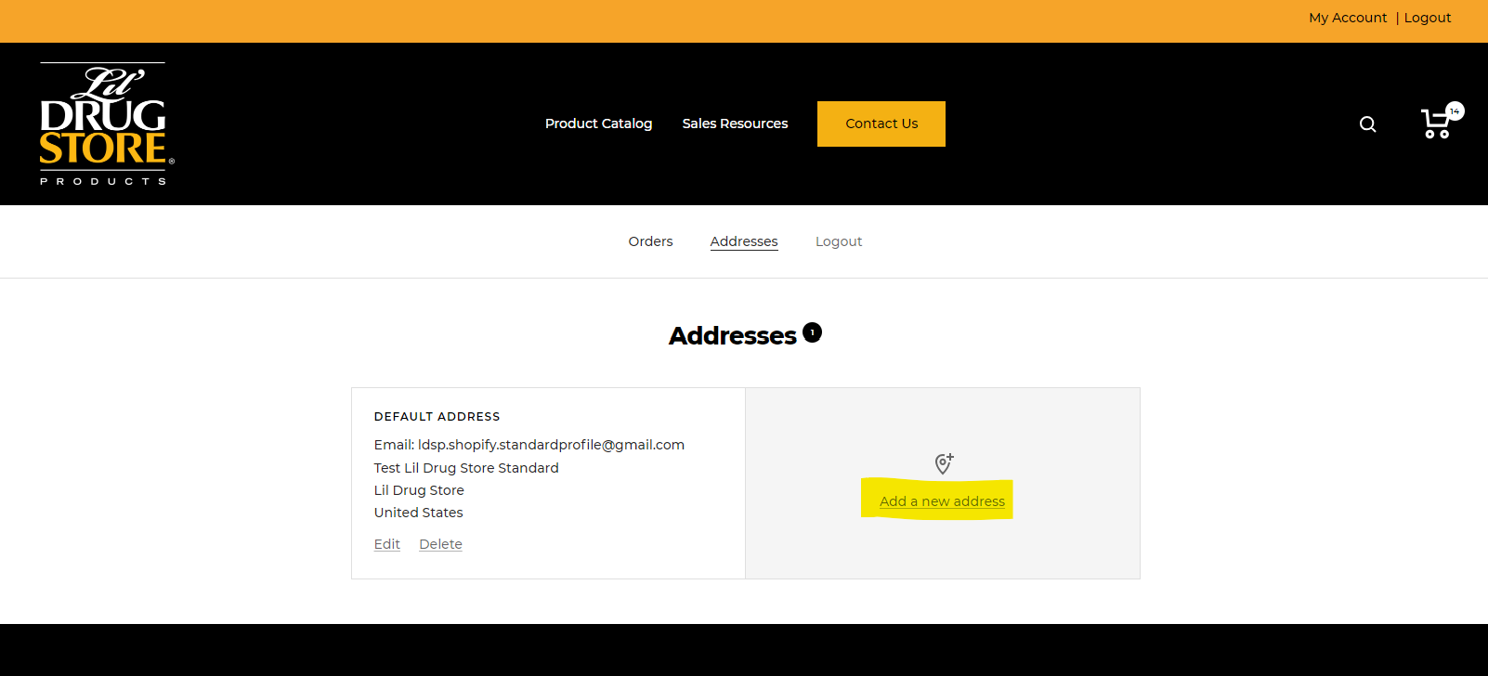
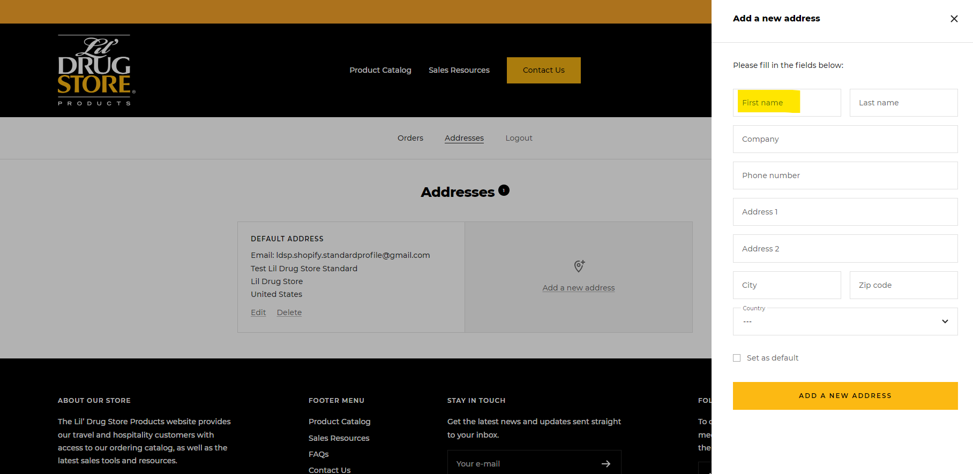

Questions? Please email Customer@lildrugstore.com

